Essex Windscreen of Need and levels of intervention

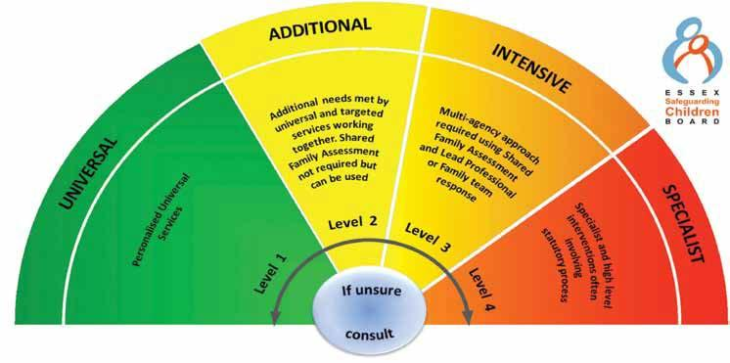

All partners working with children, young people and their families will offer support as soon as we are aware of any additional needs. We will always seek to work together to provide support to children, young people and their families at the lowest level possible in accordance with their needs

Children with Additional needs are best supported by those who already work with them, such as Family Hubs or schools, organising additional support with local partners as needed. When an agency is supporting these children, an Early Help Plan and a Lead Professional are helpful to share information and co-ordinate work alongside the child and family.

For children whose needs are Intensive, a coordinated multi-disciplinary approach is usually best, involving either an Early Help Plan or a Shared Family Assessment (SFA), with a Lead Professional to work closely with the child and family to ensure they receive all the support they require. Examples of intensive services are children’s mental health services and Family Solutions.

Specialist services are where the needs of the child are so great that statutory and/or specialist intervention is required to keep them safe or to ensure their continued development. Examples of specialist services are Children’s Social Care or Youth Offending Service. By working together effectively with children that have additional needs and by providing coordinated multi-disciplinary/agency support and services for those with intensive needs, we seek to prevent more children and young people requiring statutory interventions and reactive specialist services

