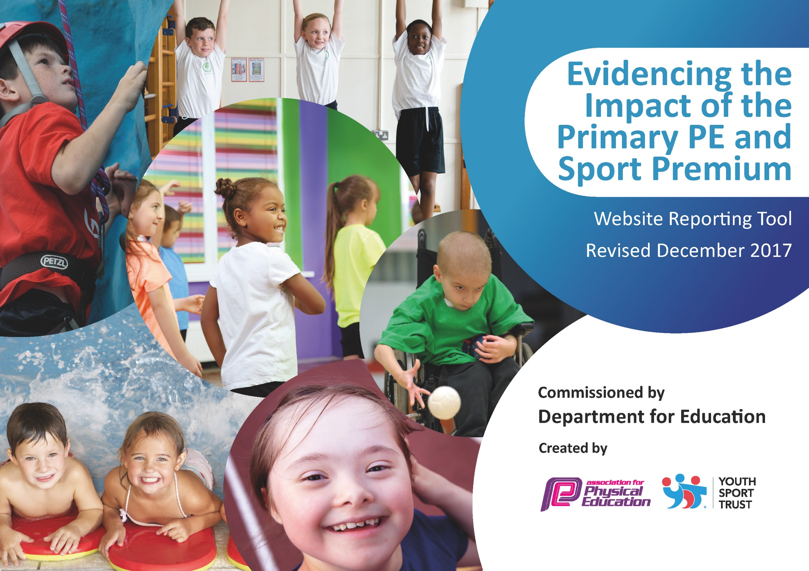

Schools must use the funding to make additional and sustainable improvements to the quality of PE and sport they offer. This means that you should use the Primary PE and Sport Premium to:

- develop or add to the PE and sport activities that your school already offers
- build capacity and capability within the school to ensure that improvements made now will benefit pupils joining the school in future years

Please visit gov.uk for the revised DfE guidance including the 5 key indicators across which schools should demonstrate an improvement. This document will help you to review your provision and to report your spend. DfE encourages schools to use this template as an effective way of meeting the reporting requirements of the Primary PE and Sport Premium.

We recommend you start by reflecting on the impact of current provision and reviewing the previous spend.
Under the Ofsted Schools Inspection Framework, inspectors will assess how effectively leaders use
the Primary PE and Sport Premium and measure its impact on outcomes for pupils, and how effectively governors hold them to account
for this.

Schools are required to publish details of how they spend this funding as well as on the impact it has on pupils’ PE
and sport participation and attainment.
We recommend regularly updating the table and
publishing it on your website as evidence
of your ongoing review into how you are using the money
to secure maximum, sustainable impact. To see an example of how to complete the table please click HERE.

Support for review and reflection - considering the 5 key indicators from DfE, what development needs are a priority for your setting and your students now and why? Use the space below to reflect on previous spend, identify current need and priorities for the future.

Key achievements to date: | Areas for further improvement and baseline evidence of need:
Sport has a high profile within our school setting, which is reflected in our Gold Sports Mark award, which we have achieved since 2013. We have sustained this standard and expectation. We strive to develop a love of sport amongst the children. Many are now taking this to a high standard out of school entering championships and area tournaments.  We provide a variety of clubs and always strive to extend these across the year groups, each year. We also aim to target groups of children that need enhanced provision. Linked to our School Improvement theme of Mindfulness, introduced a ‘Relax Kids’ initiative.  Introduced a two lunchtime clubs for specific groups of children, once a week.  Staff develop their knowledge and skills around PE through CPD from external courses and through working alongside a sports specialist from our feeder secondary school JFAN.  As well as PE lessons and after school provision, each class takes part in ‘Take 10’ sessions throughout the day/week in between lessons.  Increased provision by sports coaches to enhance preparation for sporting events with local schools.  Gym trail for children with additional needs led by a sports coach.  We have Sports Champions in year 6 that lead PE events.  Midday Assistants support Sport Champions and Playleaders and enhance the love of sport during lunchtimes.  We have ‘Walk to School’ weeks and regularly updated our school Travel Plan to enhance this message | Maintain the Gold sports mark and work towards the new Platinum level.  Continue to work towards becoming a Mindfulness school. Staff disseminate key messages and strategies across all year groups.  Look into providing more lunchtime clubs to support specific groups of children  Further develop consistency of ‘Take 10’ across the school.  Work with Working Party to explore MUGA, or alternatives, for the school.  Organise another Walk to School week.

Meeting national curriculum requirements for swimming and water safety | Please complete all of the below*:
What percentage of your current Year 6 cohort swim competently, confidently and proficiently over a distance of at least 25 metres? | In 2018 – 2019 we had 22 children in our year 6 cohort and 21 of them met the national curriculum required standard – 95%.  PE Premium has not been used for this area.
What percentage of your current Year 6 cohort use a range of strokes effectively [for example, front crawl, backstroke and breaststroke]?
What percentage of your current Year 6 cohort perform safe self-rescue in different water-based situations?
Schools can choose to use the Primary PE and Sport Premium to provide additional provision for swimming but this must be for activity over and above the national curriculum requirements. Have you used it in this way?
*Schools may wish to provide this information in April, just before the publication deadline.

Action Plan and Budget Tracking
Capture your intended annual spend against the 5 key indicators. Clarify the success criteria and evidence of impact that you intend to measure to evaluate for students today and for the future.

Academic Year: 2019/20 | Total fund allocated: £17,490 (April 2019) | Date Updated: July 2019
Key indicator 1: The engagement of all pupils in regular physical activity – Chief Medical Officer guidelines recommend that primary school children undertake at least 30 minutes of physical activity a day in school |  |  |  | Percentage of total allocation:
 |  |  |  | 67%
School focus with clarity on intended impact on pupils: | Actions to achieve: | Funding allocated: | Evidence and impact: | Sustainability and suggested next steps:
To further improve the provision and  quality of PE & School Sport at  Clavering Primary School  Broaden the sporting opportunities and experiences available to pupils.  To develop a love of sport and physical activity. | Sports Coach teaching PE to all year  groups over time – 3 x afternoons a  week  (includes preparation for Family and  Sports Partnership events)  Sustainable model  As well as PE lessons and after school provision, continue with each class taking part in ‘Take 10’ sessions throughout the day/week in between lessons.  Continue a lunchtime clubs for a specified vulnerable group with a sports coach once a week.  Midday Assistants to continue to support Sport Champions and Playleaders to enhance the love of sport during lunchtimes.  Develop Gym Trail for children with additional needs led by a sports coach. | £14,445 | Range of sports provided and experienced.  Healthy children and awareness. The majority of children will have attended a sporting event outside school.  All children will have participated in an intra school competition. maintain  Sainsbury's gold sports mark and work towards the new platinum level | Take 10 further embedded in the school day across the school.  Lunchtime groups for specified children continues.  Gym Trail regular provision
Key indicator 2: The profile of PE and sport being raised across the school as a tool for whole school improvement |  |  |  | Percentage of total allocation:
 |  |  |  | 26%
School focus with clarity on intended impact on pupils: | Actions to achieve: | Funding allocated: | Evidence and impact: | Sustainability and suggested next steps:
To continue to provide  opportunities for all children to  compete in inter school competitions.  To provide opportunities for all  children to compete in intra school competitions. | To organise teachers and  classes to enable all children to  attend outside sporting events.  To organise house/ class  Competitions - dance/ rounders  To increase house events throughout the year. | £1845 – supply and transport | The majority of children will have attended a sporting event outside school.  All children will have participated in an intra school competition. maintain  Sainsbury's gold sports mark and work towards the new platinum level | Maintain links with local schools to continue with cross working once the funding has ceased.

Key indicator 3: Increased confidence, knowledge and skills of all staff in teaching PE and sport |  |  |  | Percentage of total allocation:
 |  |  |  | 7%
School focus with clarity on intended  impact on pupils: | Actions to achieve: | Funding  allocated: | Evidence and impact: | Sustainability and suggested  next steps:
To further improve the provision and  quality of PE & School Sport at Clavering Primary School  Ensure that PE & School Sport is judged as at least good by external monitoring.  Broaden the sporting opportunities and experiences available to pupils.  To develop a love of sport and physical activity | External PE coach/teacher  working and teaching alongside  Clavering staff  Training events for teachers  across our cluster of schools  with specialist coaches | £1200 | Staff expertise increased/ developed | Staff to share CPD to increase sustainability across the school.  Maintain links with Lisa Dunlop from JFAN.
Key indicator 4: Broader experience of a range of sports and activities offered to all pupils |  |  |  | Percentage of total allocation:
 |  |  |  | 67%
School focus with clarity on intended  impact on pupils: | Actions to achieve: | Funding  allocated: | Evidence and impact: | Sustainability and suggested  next steps:
To further improve the provision and  quality of PE & School Sport at  Clavering Primary School  Broaden the sporting opportunities and experiences available to pupils.  To develop a love of sport and physical activity. | Sports Coach teaching PE to all year  groups over time – 3 x afternoons a  week  (includes preparation for Family and  Sports Partnership events)  Sustainable model  As well as PE lessons and after school provision, continue with each class taking part in ‘Take 10’ sessions throughout the day/week in between lessons.  Continue a lunchtime clubs for a specified vulnerable groups with a sports coach once a week.  Midday Assistants to support sport champions and Playleaders to enhance the love of sport during lunchtimes.  Gym trail for children with additional needs led by a sports coach to be more frequent. | £14,445 | Range of sports provided and experienced.  Healthy children and awareness. The majority of children will have attended a sporting event outside school.  All children will have participated in an intra school competition. maintain  Sainsbury's gold sports mark and work towards the new platinum level | Take 10 embedded in the school day across the school.  Lunchtime groups for specified children continues.  Gym Trail regular provision
Key indicator 5: Increased participation in competitive sport |  |  |  | Percentage of total allocation:
 |  |  |  | 26%
School focus with clarity on intended  impact on pupils: | Actions to achieve: | Funding  allocated: | Evidence and impact: | Sustainability and suggested  next steps:
To continue to provide  opportunities for all children to  compete in inter school competitions.  To provide opportunities for all  children to compete in intra school competitions. | To organise teachers and  classes to enable all children to  attend outside sporting events.  To organise house/ class  Competitions - dance/ rounders  To increase the number of house events throughout the year. | £1845 – supply and transport | The majority of children will have attended a sporting event outside school.  All children will have participated in an intra school competition. maintain  Sainsbury's gold sports mark and work towards the new platinum level | Maintain links with local schools to continue with cross working once the funding has ceased.

