



**Creative work for key stage 2 -**

**Roll the dice and complete the dance of the number you get**

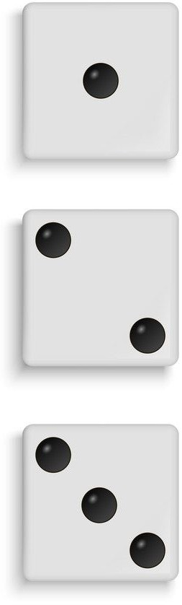

**Uptown funk**

<https://www.youtube.com/watch?v=aXDvdCDAyHo>

**I feel alive**

<https://www.youtube.com/watch?v=RCgtcEz6SGk>

**You’re the one that I want**

<https://www.youtube.com/watch?v=Q7aLjjkB9JQ>

**Can’t stop the feeling**

<https://www.youtube.com/watch?v=seg8bLgxV1g>

**Dance monkey**

<https://www.youtube.com/watch?v=wpz36D0WaDg>

**We will rock you**

<https://www.youtube.com/watch?v=9HtRyc3ixrc>

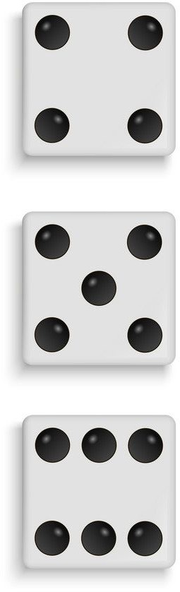

Which is your favourite one?