|  |  |  |  |  |  |  |
| --- | --- | --- | --- | --- | --- | --- |
|  | Autumn 1 | Autumn 2 | Spring 1 | Spring 2 | Summer 1 | Summer 2 |
| Reception | Meaning to marks to CVC to simple sentences  Fiction:  •topic related sentences linking to a familiar story  Non fiction:  •captions, labels •simple facts  •poetry:  •rhyming CVC words | Meaning to marks to CVC to simple sentences  Fiction:  •topic related sentences linking to a familiar story  Non fiction:  •captions, labels •simple facts  •poetry:  •rhyming CVC words | Meaning to marks to CVC to simple sentences  Fiction:  •traditional tales  Non fiction:  •role play: menus, prescriptions, invitations, notes •lists  Poetry:  •rhyming CVC words  •Julia Donaldson focus | Meaning to marks to CVC to simple sentences  Fiction:  •traditional tales  Non fiction:  •role play: menus, prescriptions, invitations, notes  •lists  •recounts  Poetry:  •rhyming CVC words | Meaning to marks to CVC to simple sentences  Fiction:  •fantasy sentence, e.g. If I had a flying carpet, I would go …  • simple stories  Non Fiction:  •letters in meaningful context, shared writing  Poetry  •changing words to alternative endings  •poems from around the world | Meaning to marks to CVC to simple sentences  Fiction:  •fantasy sentence, e.g. If I had a flying carpet, I would go …  • simple stories  Non Fiction:  •letters in meaningful context, shared writing  Poetry  •changing words to alternative endings  •poems from around the world |
| Year 1 | Fiction- stories with familiar settings  Stories with predictable phrasing and repeating patterns | Film study - The Girl with the Yellow Bag.  setting  description  short narrative  Labels, lists and signs  Poems -rhyming couplets | Traditional tales  Letters and description | Instructions  Super Hero Comic Strip  Poems about the senses -vocabulary building | Fantasy stories  Information texts | Take one poet -poetry appreciation  Film study - Owl Babies. narrative |
| Year 2 | Traditional tales, fables with morals    Information texts | Letters and postcards  Instructions  Take one poet -poetry appreciation | Fiction  Recounts - first person | Information writing  Film study | Stories by the same author  Report – assemble information | Film study  Poems |
| Year 3 | Narrative -Stories from other cultures | Poems from around the world | Recount- Diaries  Film Study-The Littlest Shoemaker  (Persuasive adverts) | Performance Poetry  Information- Non chronological reports  Book Study-The Miraculous Journey of Edward Tulane (narrative/letter writing) | Recounts-Newspaper reports film unit (Spy Fox)  Instructions and explanation  Persuasion-Film unit  For the Birds | Film study- The Black Hat (Narrative,  character description, figurative language)  Book study-The Iron Man-Ted Hughes  (Description, action sequences, diary, instructions) |
| Year 4 | Fables  Instructions and explanation | Biography  Poetry -syllabic form  Film study | Myths and legends  Recounts | Performance Poetry  Persuasive writing | Stories with Humour    Chronological Reports  List Poems and Kennings | Stories from other Cultures  Film Study  Odes and Insults Poems |
| Year 5 | Classic Fiction  Recounts  Film Study | Instruction and Explanation  Travel Writing  Classic poetry | Faraway Fiction  Argument and Debate | Reports and Journalistic writing  Poetic Style | Autobiography  Non Chronological Reports  Plays | TV Journalism  Letters and Correspondence |
| Year 6 | Significant Author study (Philip Pullman)  Recounts -write in role | Historical Fiction (WW1)  Instruction and Explanation  Choral and Performance Poetry | Flashbacks  Film narrative (Francis)  Narrative Poetry | Reports and Information  Discussion and persuasion | Revision units  Non Chronological Reports | Film Study (Titanium)  Poet study -Emily Dickinson  or  Classic Fiction (link to end of year show) |

**Guided reading – in addition to regular individual reading (three times weekly, more often according to need) in Key Stage 1 and lower key stage 2,** all pupils in Key Stage 1 and 2 take part in weekly guided reading session where they use a range of activities to develop their reading comprehension skills. Children all have the opportunity to change their reading books daily in school, in addition to a weekly library session where they may also borrow books to take home. We use the Vipers approach to ensure all key skills are covered.

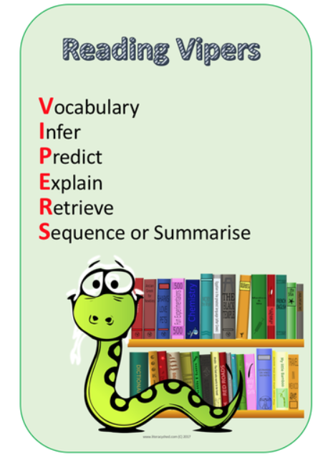

**Grammar and spelling**– all pupils in Key Stage 1 and 2 study the expectations of the grammar and spelling curriculum both within English lessons and in a discrete weekly 20 minute lesson.

**Handwriting** – is practised daily with a discrete weekly lesson of 20 minutes. We use a cursive handwriting style from Foundation Stage to year 6. Children first learn to form letters starting on the line and ending with a flick, when they are ready they learn to join.

Have scanned example can’t attach???