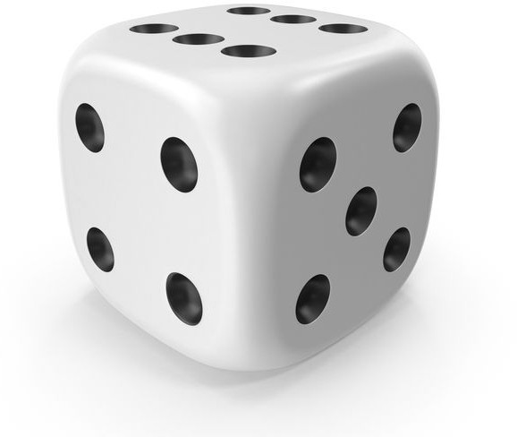



**Key stage 1**

**Roll the dice and complete the dance of the number you get**

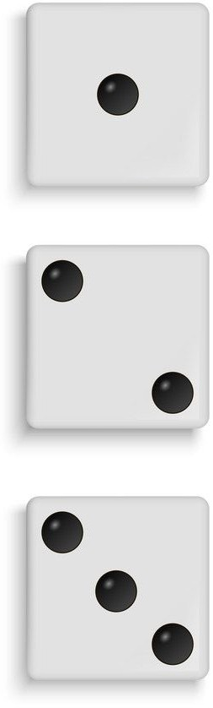

**Break this down**

<https://www.youtube.com/watch?v=PoK6IA4kHSA&feature=youtu.be>

**Andy’s wild workout**

BBC iPlayer series 1 under the sea on CBBC

**The Jungle Book**

<https://www.youtube.com/watch?v=a0OMDUJEK1I&feature=youtu.be>

**Cosmin kids’ yoga**

<https://www.youtube.com/watch?v=9JI01thiHYI&feature=youtu.be>

**Under the sea**

<https://www.youtube.com/watch?v=rLfsP_G7m4c&feature=youtu.be>

**Your welcome from Moana**

<https://www.youtube.com/watch?v=1iRDQQ1pZKQ&feature=youtu.be>

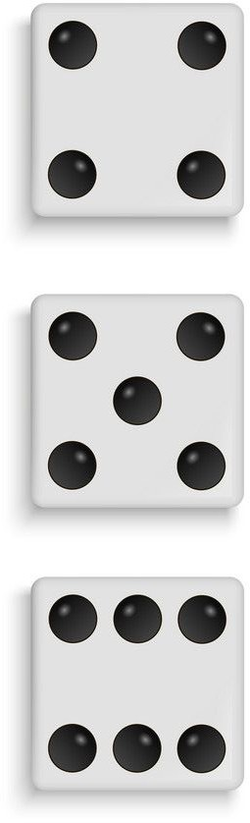

What is your favourite?

Roll the dice again and do another song!