Year 1/2 Activekidsdobetter uk
Resources/active classroom
Task 1 –Roll the dice perform the number as on the dice. Have 6 throws and perform each action for 30 seconds.
Task 2 select to go for-
Gold task –total score on the dice is 40 perform each throw for 20seconds. Keep a total running as you perform.
Silver task - total score on the dice is 30 perform each throw for 20seconds Keep a total running as you perform m
Bronze total score on the dice is 20 perform each throw for 20seconds keep a total running as you perform

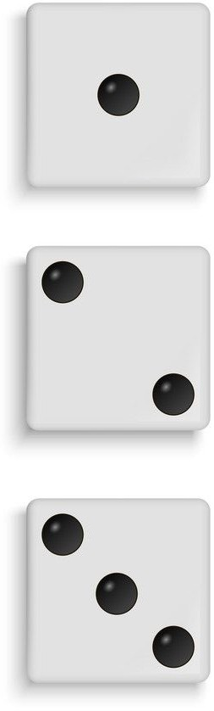
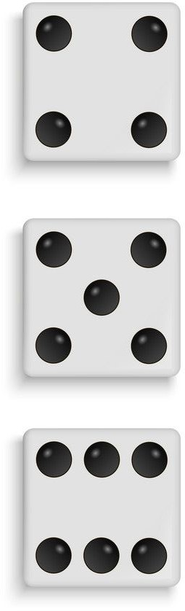

Up the ladder for 1 minute

Gallop for 45 seconds

Wiggle for 45 seconds

Spotty dog for 45 seconds

Silly Sailor for a minute

Power Range for 45 seconds

Can you Play against a family member? Who completes task 2 first after you have selected gold, silver or bronze.

