Year 3/4 Activekidsdobetter uk
Resources/active classroom
Task 1 –Roll the dice perform the number as on the dice. Have 6 throws and perform each action for 1 minute.
Task 2 select to go for-
Gold task –total score on the dice is 60 perform each throw for 20seconds.
Silver task - total score on the dice is 40 perform each throw for 20seconds
Bronze total score on the dice is 30 perform each throw for 20 se20seconds

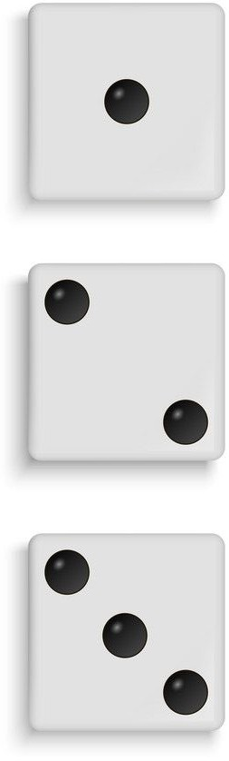
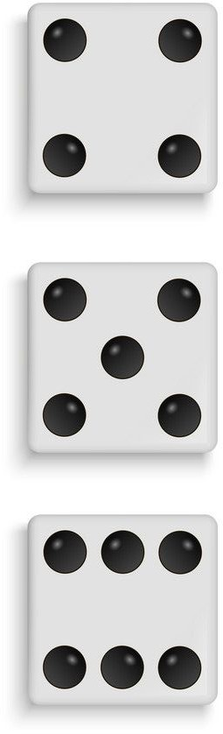

Up the ladder for 1 minute

Spotty dog for 1 minute

Wiggle for 1 minute

Hopscotch for 1 minute

Clap under the ladder for 1 minute

Silly Sailor for a minute

Can you Play against a family member? Who completes task 2 first after you have chosen gold, silver or bronze.

