

**Year 3/4: Cricket catching skills**

Can you do the following activities as well as Joe Root? Have a go!

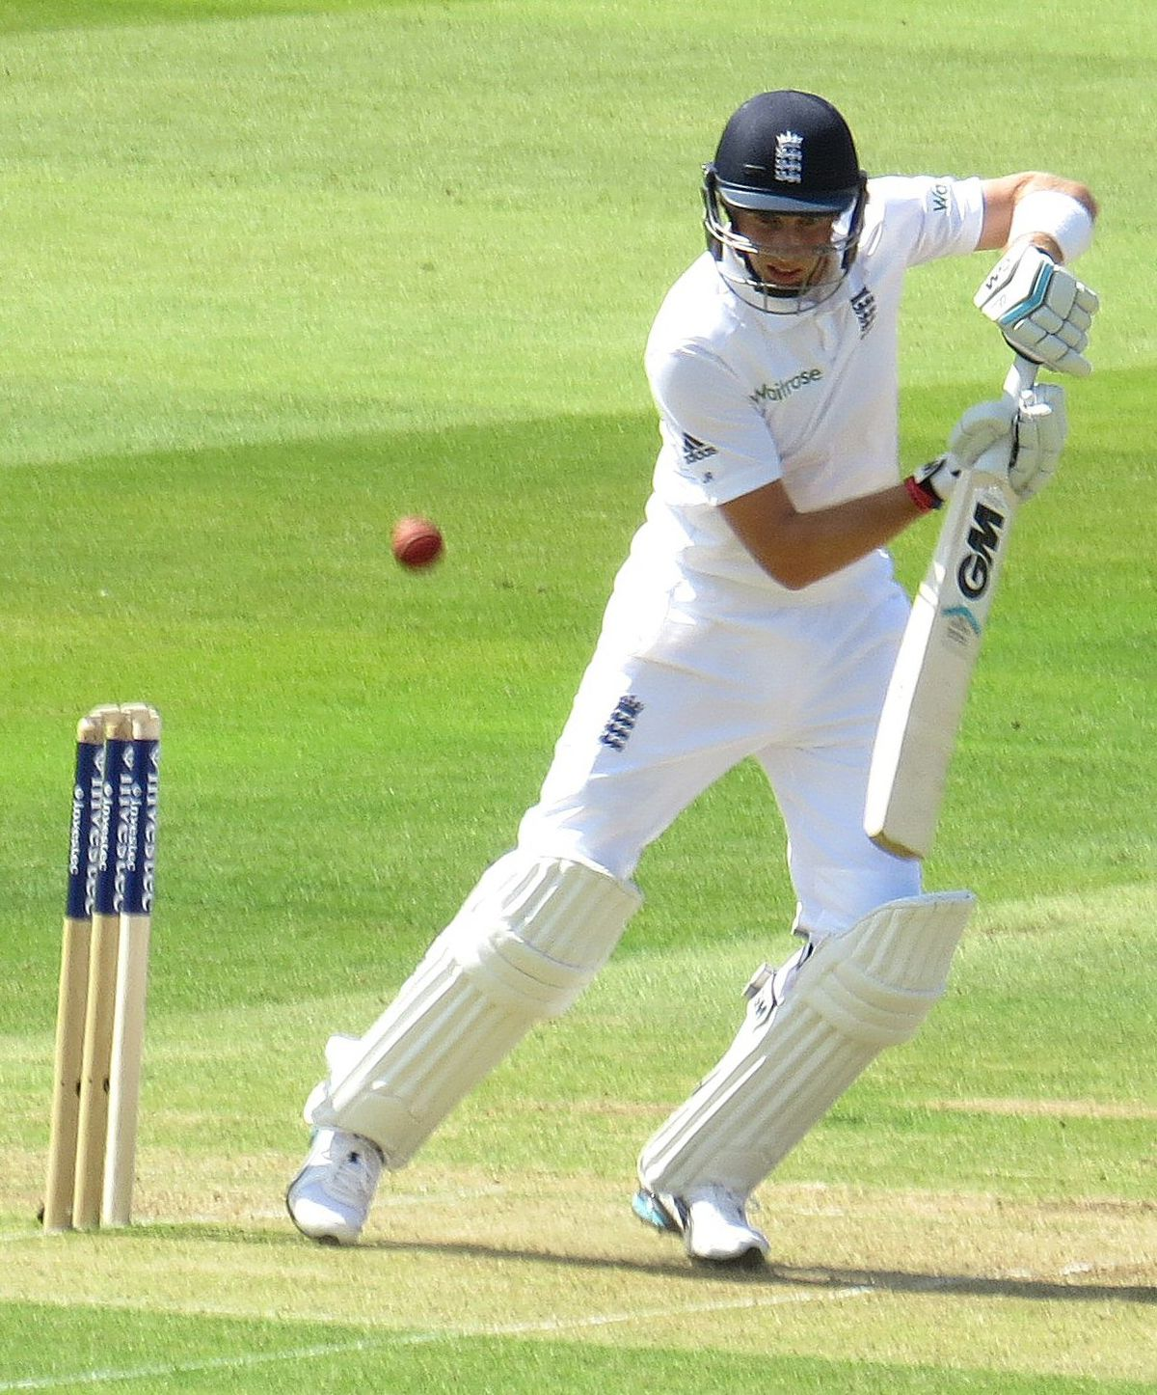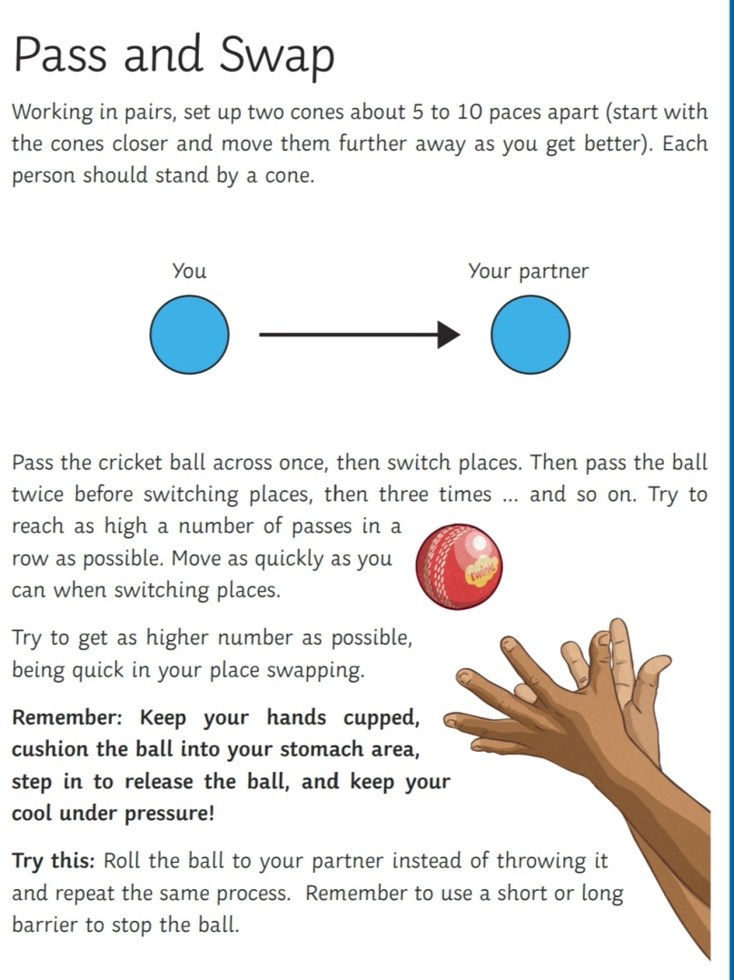

Can you catch with one hand ?

Try throwing with your non-dominant hand!

Try a different size ball !

1. Throw the ball above your head.

2. Try to spin as many times as you can before catching the ball. Don’t let it bounce!

Spin and catch

1. Throw the ball above your head.

2. Try to clap as many times as you can before catching the ball.

Joe Root – England Men’s Test Cricket Captain

Joe is 29 years old and plays cricket for Yorkshire. He first played cricket for England in 2012 and took over as England test captain in 2017.

Clap and catch

Pass and swap