As you can now go out and do more exercise every day, here are some things you can look for on your travels!
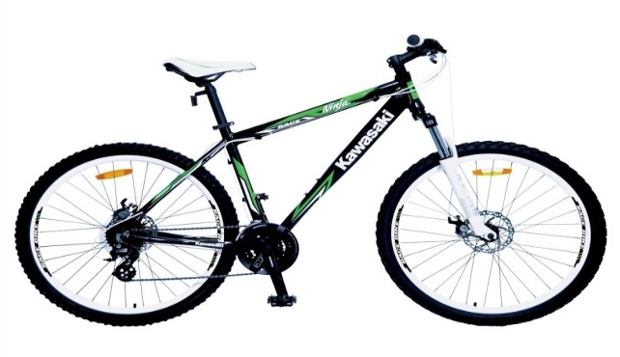
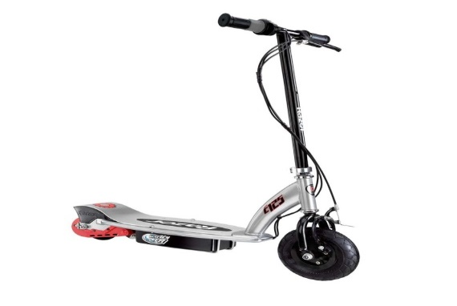

Plan a new bike ride! Find a new scooter route!
Here are some things you can see on your journey
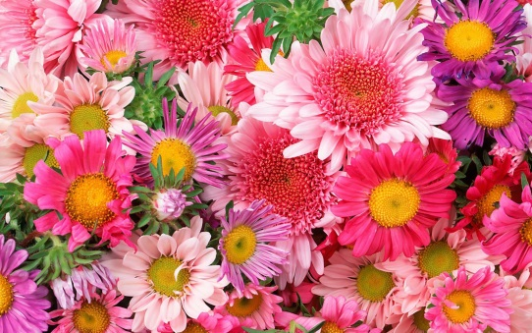  Pretty flowers!  What different flowers can you spot? | 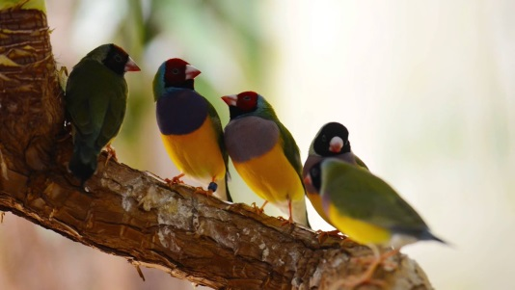  Some birds!  What different birds  Can you spot? | Rainbow!  How many have you spotted in houses?
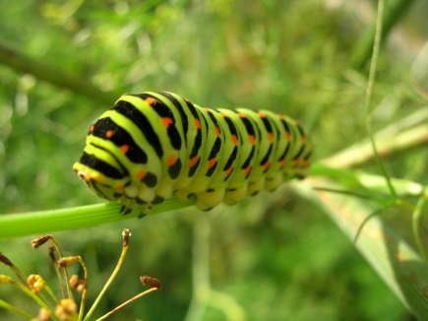  Creep crawly caterpillar! | 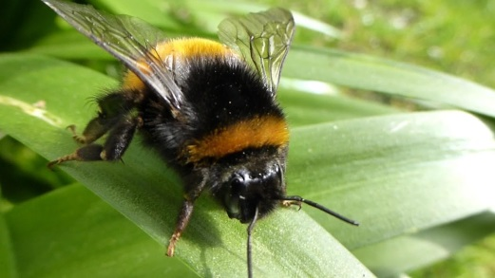  Buzzy bumble bee!  How many can you spot? | 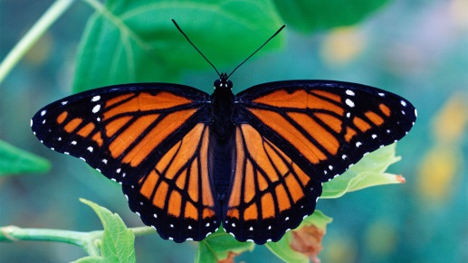  Butterfly!  What different designs do they have?

