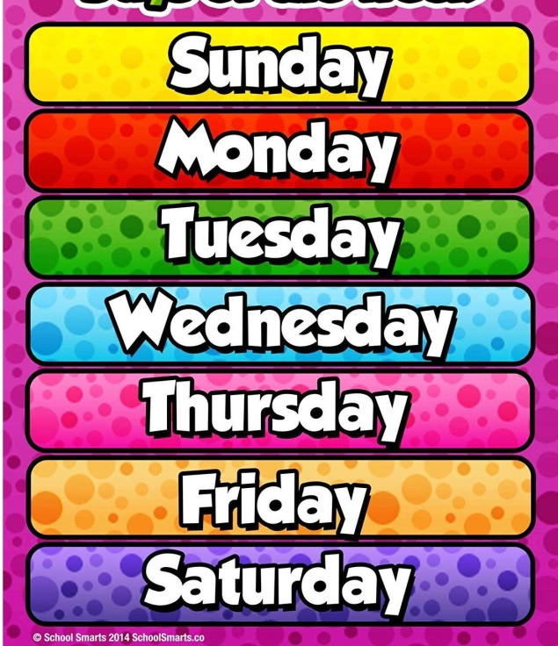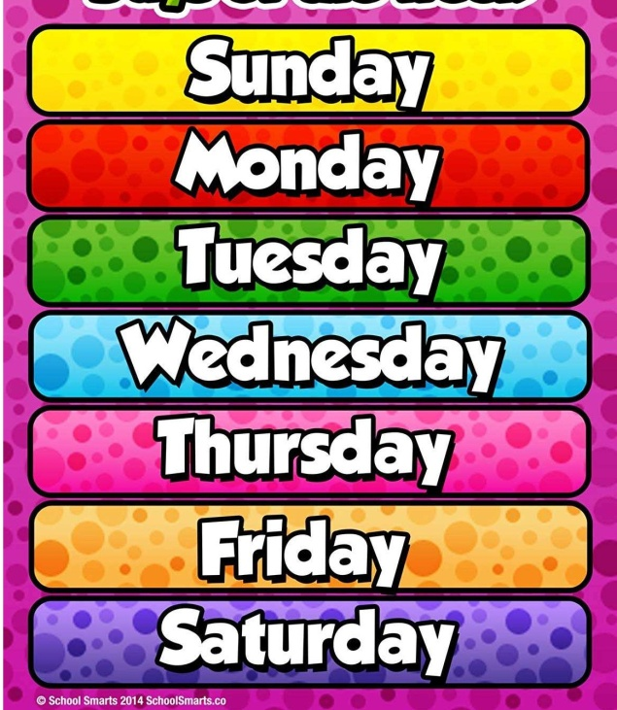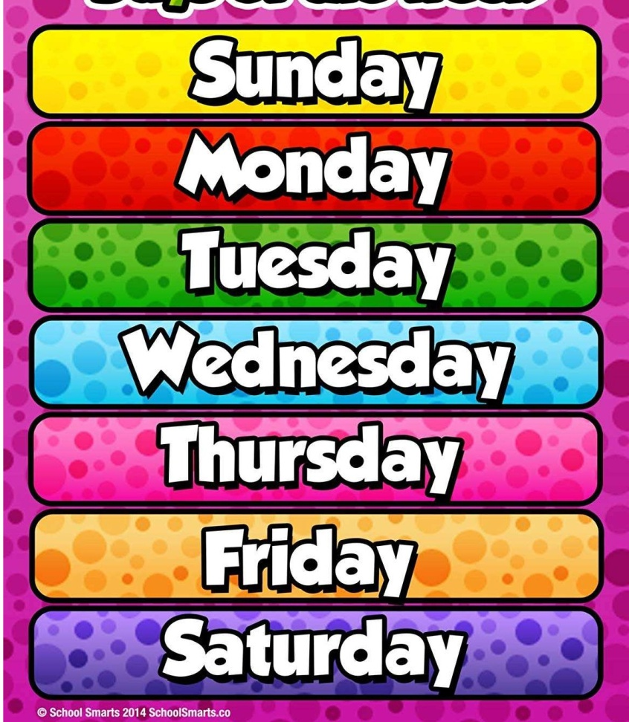

Daily challenges

Fitness challenge

<https://www.youtube.com/watch?v=GHCqRsrQwNU>

Cross the river challenge

<https://www.youtube.com/watch?v=xp5ClsXs-b8&list=PLnwoPgo24bhmqV8Y76iXnwYw9T9AlxbqJ&index=8&t=0s>

Choose your favourites to try again!

Choose a different one each day!

Disney dance challenge

<https://youtu.be/mUSgKSgS4-E>

Yoga freeze challenge

<https://youtu.be/EcnQNWBXE5s>

Teddy bear challenge

<https://youtu.be/whPptTaKMtA>

on Youtube ...