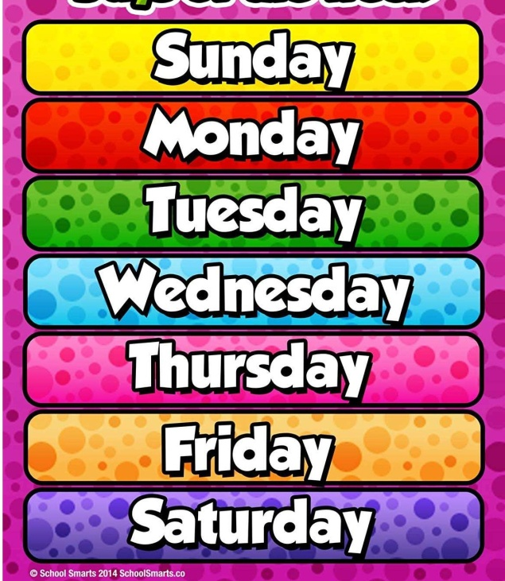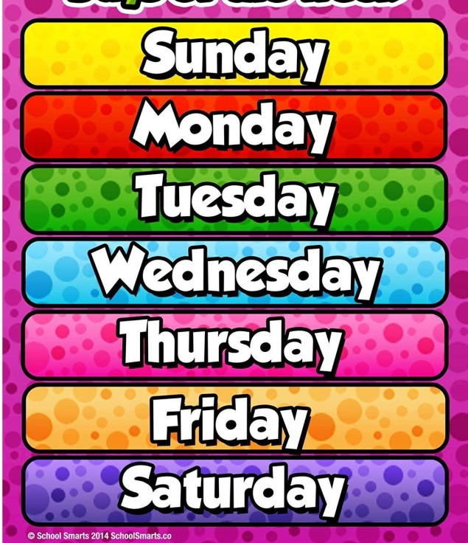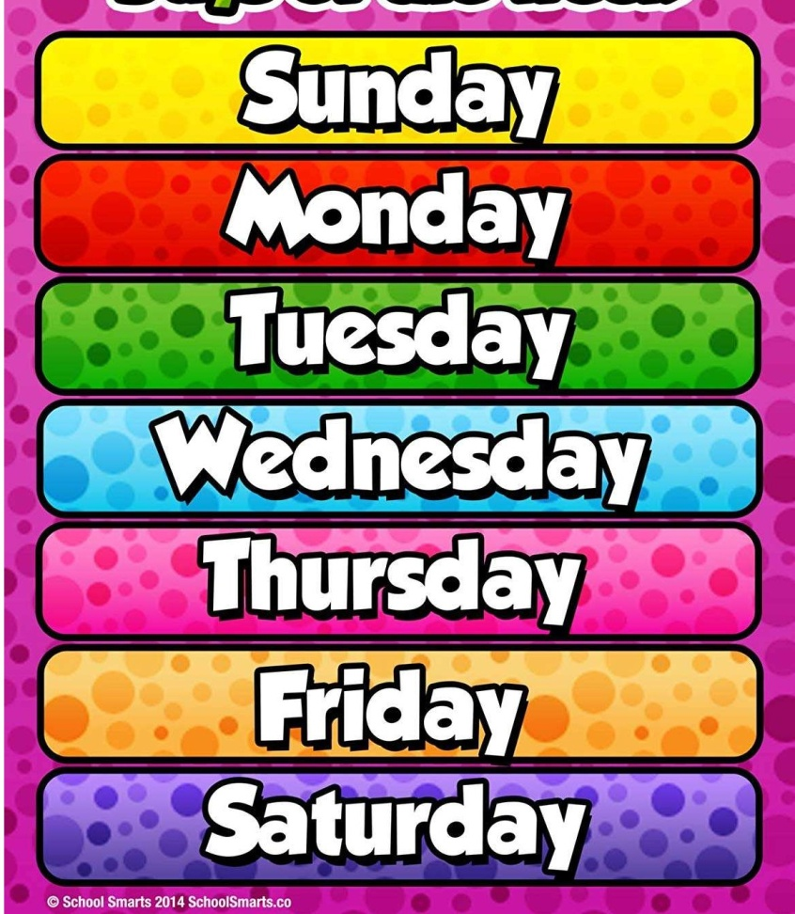

Target treasure challenge

<https://www.youtube.com/watch?v=N9XU5YKLbx8&list=PLnwoPgo24bhmqV8Y76iXnwYw9T9AlxbqJ&index=32&t=0s>

Tennis catching challenge

<https://youtu.be/trSf3YNTXJA>

Right way, wrong way

<https://www.youtube.com/watch?v=YpnSgcqVxXg&list=PLnwoPgo24bhmqV8Y76iXnwYw9T9AlxbqJ&index=13&t=0s>

Pokemon fitness

<https://youtu.be/VW_ST68v8TM>

Bob it!

<https://youtu.be/CIeiNqlb3MM>

Choose a different one each day!

Choose your favourites to try again!

on Youtube ...

Yr 3/4 daily challenges