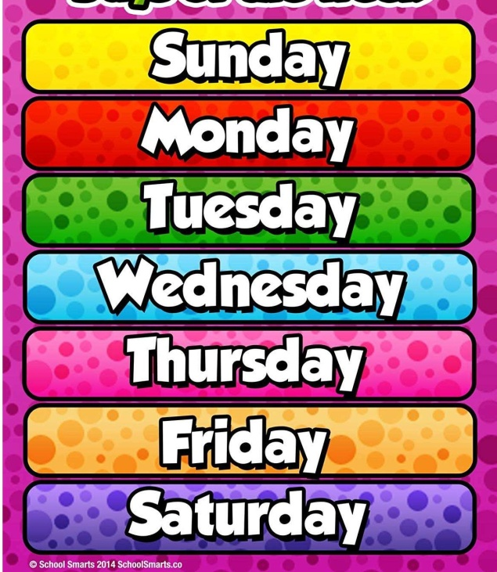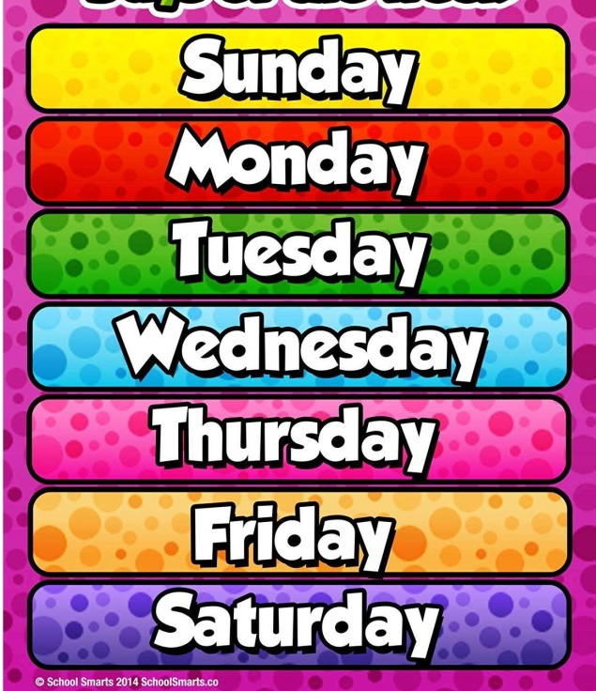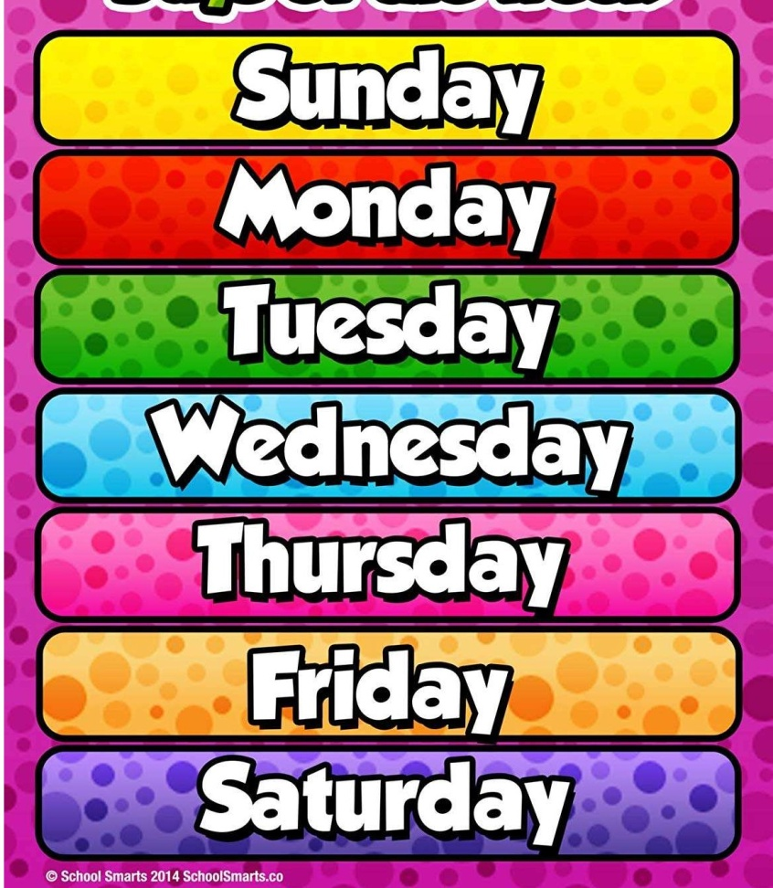

Hockey challenge – agility run

<https://youtu.be/TA0cIrTIb4M>

Harry Potter workout

<https://youtu.be/NTcvqBgiT8I>

Disney fitness circuit

<https://youtu.be/hsfheb5UwdE>

Dodgeball skills

<https://youtu.be/kmR7M4xhvQQ>

Football challenge – hit the target

<https://www.youtube.com/watch?v=HREjrk1bR-k>

Choose a different one each day!

Choose your favourites to try again!

on Youtube ...

Yr 5/6 daily challenges