Clavering County Primary School Guide to using Microsoft Teams

The school are now using an application called Microsoft Teams for communication and collaboration purposes.
This software will allow our teachers to share resources and most importantly interact with pupils and parents electronically at home or on the move.
For the best experience, we recommend you use a Windows based computer that has speakers and a microphone (or a headset).
Other mobile devices can also be used for Microsoft Teams (Apple, Android and Chrome Book) by using a web browser or a dedicated app. We recommend you try and install the application for your chosen device to provide the richest experience for yourself and your child.
Please Note: If your device is used for multiple users (e.g. you use Microsoft Teams for work or more than one child is accessing Microsoft Teams), please read the comments at the end of this document.

Please use the instructions below to download the correct app for your chosen device.

Windows Computer
- Go to https://www.microsoft.com/en-gb/microsoft-365/microsoft-teams/download-app

- Click Download for desktop
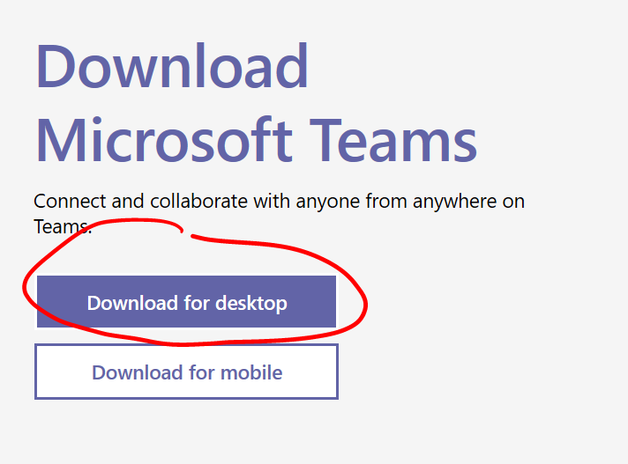
- Click download Teams
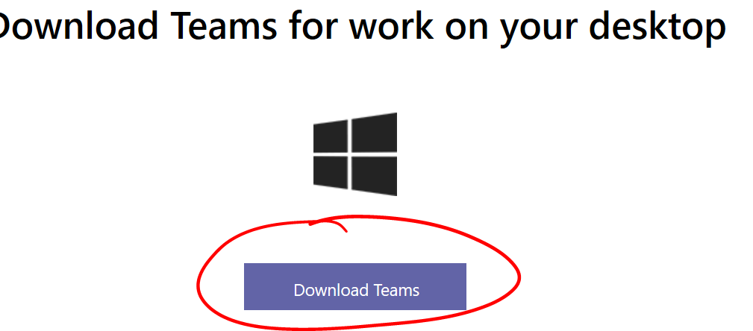

- Click Run
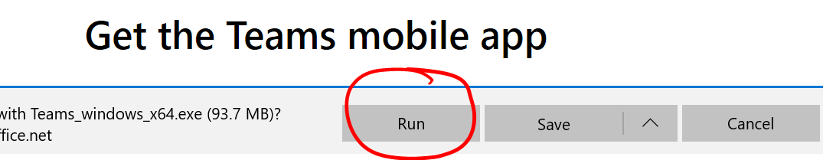

- At the login screen enter the pupils email address provided in the parentmail message. In most cases this will be first initial and surname e.g. John Smith would be jsmith@clavering.essex.sch.uk

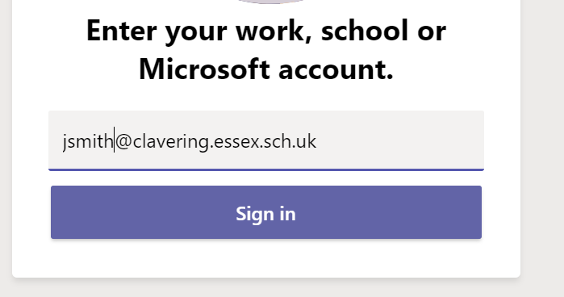

- Click Sign in.
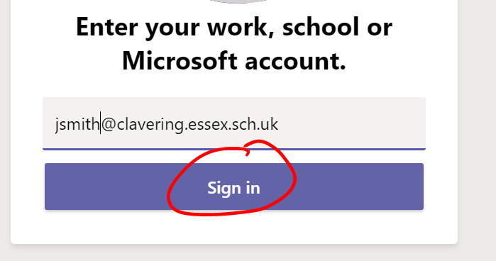

- Check that your child’s email address has been automatically added to the login box then enter the password supplied via parentmail. Please note the password is case sensitive.
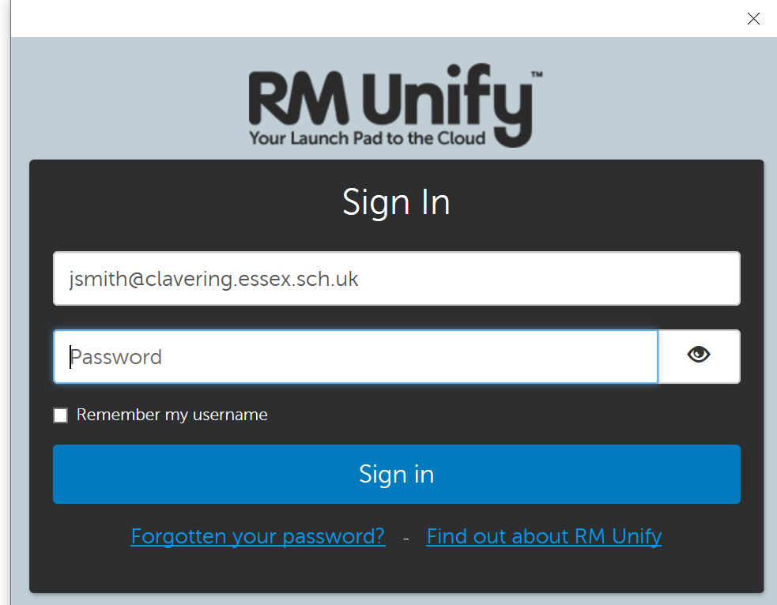

- Click Sign in

- Untick let my organisation manage my device
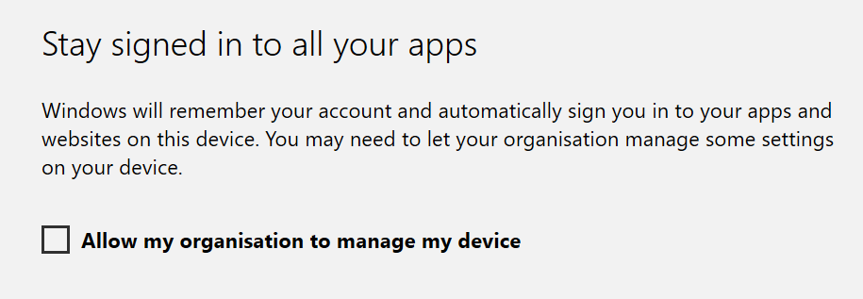

- Click No, sign into this app only
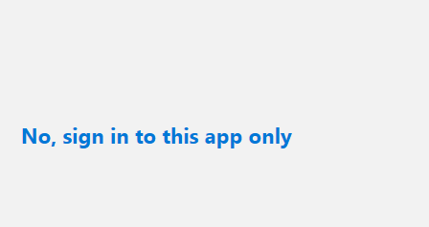

- You will now be using MS Teams. You should see your child’s class listed.
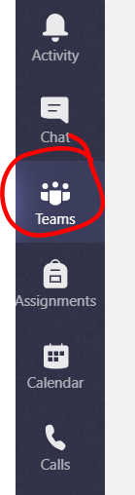

Android

- Go to the Play Store and search for Microsoft Teams
- Click install
- Click Open
- If other accounts are listed, selected ‘sign in with another account’
- Enter email address supplied in the parentmail message. In the majority of cases, this is first initial and surname e.g John Smith would be jsmith@clavering.essex.sch.uk.
- Click Sign In
- Enter password provided in parentmail (case sensitive)
- Click ‘Next’, then ‘Next’, then ‘Got it’
- Click on Teams and your child will see their class

Apple iPad/iPhone
- Open App Store
- Search for Microsoft Teams
- Click Get and install app
- When prompted to log in, enter email address supplied in the parentmail message. In the majority of cases, this is first initial and surname e.g John Smith would be jsmith@clavering.essex.sch.uk. Enter password provided in parent mail (case sensitive)
- Click on Teams and your child will see their class

Any device using a web browser

- Go to https://teams.microsoft.com
- Enter email address supplied in parentmail
- You will be redirect to RM Unify login page.
- Enter the password supplied in parentmail (case sensitive)
- Click on Teams and your child will see their class
MS Teams already installed on your device or multiple people need to access Microsoft Teams.

If more than one person needs to access Microsoft Teams on the same device ensure they log out to allow the others to login with their own details.
- Click the user initials or name
- Click sign out
- Enter login details for new user

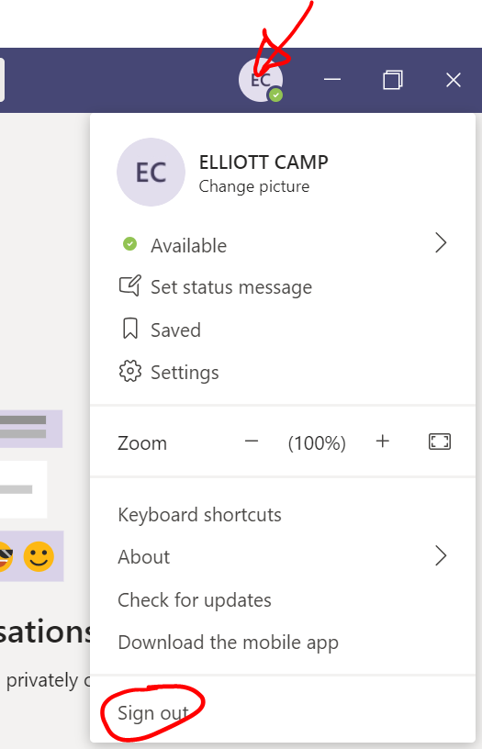

If you are experiencing any problems with the above, please email both alices@clavering.essex.sch.uk AND admin@clavering.essex.sch.uk.
We will pick these up between 8-10am on Monday morning.

