 | Autumn 1 | Autumn 2 | Spring 1 | Spring 2 | Summer 1 | Summer 2
Reception | Meaning to marks to CVC to simple sentences  Fiction:  •topic related sentences linking to a familiar story  Non fiction:  •captions, labels •simple facts  •poetry:  •rhyming CVC words | Meaning to marks to CVC to simple sentences  Fiction:  •topic related sentences linking to a familiar story  Non fiction:  •captions, labels •simple facts  •poetry:  •rhyming CVC words | Meaning to marks to CVC to simple sentences  Fiction:  •traditional tales  Non fiction:  •role play: menus, prescriptions, invitations, notes •lists  Poetry:  •rhyming CVC words  •Julia Donaldson focus | Meaning to marks to CVC to simple sentences  Fiction:  •traditional tales  Non fiction:  •role play: menus, prescriptions, invitations, notes  •lists  •recounts  Poetry:  •rhyming CVC words | Meaning to marks to CVC to simple sentences  Fiction:  •fantasy sentence, e.g. If I had a flying carpet, I would go …  • simple stories  Non Fiction:  •letters in meaningful context, shared writing  Poetry  •changing words to alternative endings  •poems from around the world | Meaning to marks to CVC to simple sentences  Fiction:  •fantasy sentence, e.g. If I had a flying carpet, I would go …  • simple stories  Non Fiction:  •letters in meaningful context, shared writing  Poetry  •changing words to alternative endings  •poems from around the world
Year 1 | Fiction- stories with familiar settings  Stories with predictable phrasing and repeating patterns  Paper Dolls – Julia Donaldson(repeated phrasing)  Highway rat  Dogger (familiar setting)  Amazing Grace | Film study - The Girl with the Yellow Bag.  setting  description  short narrative  Labels, lists and signs  Poems -rhyming couplets  Not a stick (labels and signs)  At the zoo  Hickory dickory Dock  Bed in Summer  The Caterpillar  Down by the Dustbin | Traditional tales  Letters and description  Rapunzel  This is the house that jack built  The day the craons quit  Aesop fable (letter and description) | Instructions  Poems about the senses -vocabulary building  Don’t let the pigeon drive the bus  Jam sandwich -making/washing hands  I can see, hear, feel and smell (senses poem) | Fantasy stories  Information texts  Pattan’s Pumpkin  The Gigantic turnip  Tigress (information text) | Poetry appreciation  Narrative  Thinker  Film Study (Owl babies)
Year 2 | Traditional tales, fables with morals  Information texts | Letters and postcards  Instructions  Take one poet -poetry appreciation | Fiction  Recounts - first person | Information writing  Film study  The Girl with the Yellow Bag | Stories by the same author  Report – assemble information | Film study  The Bridge  Poems
Year 3 | Stories by the same author: Roald Dahl  Instructions and explanations | Poems from around the world  Film Study: The Black Hat (Narrative, character description, figurative language) | Recount- Diaries  Film Study-The Littlest Shoemaker  (Persuasive adverts) | Performance Poetry  Book Study-The Miraculous Journey of Edward Tulane (narrative/letter writing) | Recounts-Newspaper reports film unit (Spy Fox)  Information – Non Chronological Reports | Book study-The Iron Man-Ted Hughes  (Description, action sequences, diary, instructions)  Letters
Year 4 | Fables  Information texts (Film Study: The Present) | Poetry – Syllabic form  Newspaper reports (Book study: Tuesday) | Roman Myths and legends  Stories with humour  Odes and Insults poems | Performance Poetry  Stories from other cultures | Biography (WWll themed)  Chronological Reports (Book study: George’s Marvellous medicine)  List Poems and Kennings | Persuasive writing (Book study: Great Kapok tree)  Diary  (Film Study: There’s a Rangtan in my bedroom)
Year 5 | Letters and correspondence (Alchemist’s Letter)  Greek Myths | Argument and debate (Elgin Marbles)  Classic poetry (Highwayman) | Classic fiction (Hobbit)  Autobiography (Pere Lachaise) | Explanation (rivers)  Poetic style (river poems/Convergence of the Twain) | Journalistic writing (DT link) and TV journalism  Visual literacy (Swing of Change) | Plays (Shakespeare)  Non Chronological Reports (biomes)  Travel Writing (biomes)
Year 6 | Historical Fiction (WW1)  Instruction and Explanation  Choral and Performance Poetry | Significant Author study (Philip Pullman)  Fiction - outsiders  Recounts – writing in role | Flashbacks  Film narrative (Francis)  Narrative Poetry | Reports and Information  Discussion and persuasion | Revision units  Non Chronological Reports | Film Study (Titanium)  Poet study -Emily Dickinson  or  Classic Fiction (link to end of year show)

Guided reading – in addition to regular individual reading (at least once weekly with an adult and more often, according to need) in Key Stage 1 and lower key stage 2, all pupils take part in weekly guided reading session where they use a range of activities to develop their reading comprehension skills. Children have the opportunity to change their reading books regularly in school. They also have regular access to library session where they may also borrow books to take home. We use the Vipers approach to ensure all key skills are covered.
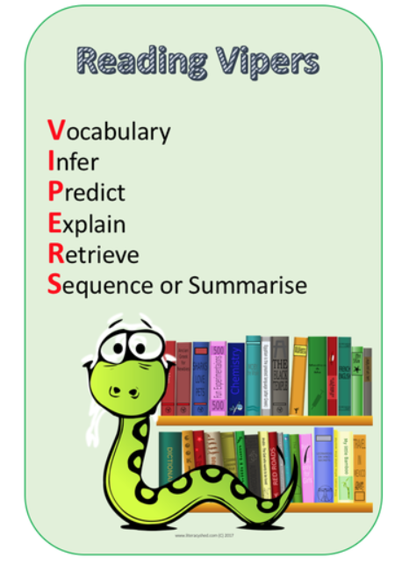
Grammar and spelling – all pupils in Key Stage 1 and 2 study the expectations of the grammar and spelling curriculum both within English lessons and in discrete sessions, depending on age and need.

Handwriting – is practised daily in EYFS and Key stage 1. Handwriting is practised regularly in Key stage 2, depending on the age and needs of the children. We use a cursive handwriting style from Foundation Stage to year 6. Children first learn to form letters starting on the line and ending with a flick, when they are ready they learn to join.

