MENU VEGETARIAN SUMMER TERM
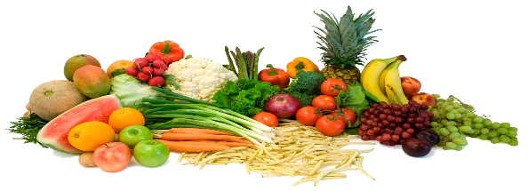
This Photo by Unknown Author is licensed under CC BY-NC
 | MONDAY | TUESDAY | WEDNESDAY | THURSDAY | FRIDAY
WEEK ONE | Picnic Day  Cheese Roll | Vegetarian Meatballs | Chicken Style Pieces In a Yorkshire | Homemade Breaded Quorn Fillet | Omelette
WEEK TWO | Pasta Bar | Sticky Chicken Style Pieces | Meat Free Sausage Roll | Quorn Southern Fried Burger | Quorn  Crispy Dippers
WEEK THREE | Mini Baguette Pizza | Chicken Style Pieces Fajita Crunchy Tacos | Richmond Meat Free Sausages | Veggie Mince Bolognese | Birds Eye Veggie Fingers
All meal accompaniments are the same as with the regular menu
Available Daily – Milk or water, fresh salad & fruit bar.
Yoghurts are available as an alternative dessert. Children with allergens will be catered for accordingly.

